For PupperCoinCrowdsale.sol

1. Set Complier to 0.5.5+
2. Compile and ensure checkmark appears

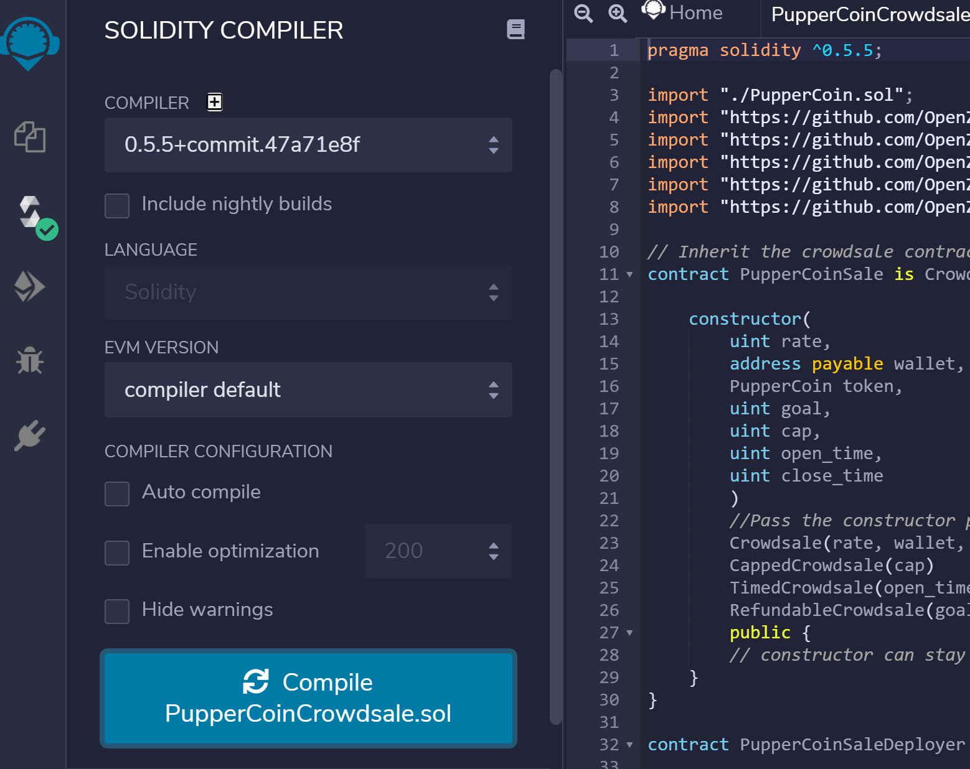

1. Move to Deploy & Run Transactions
2. Change environment to Injected Web3
3. Change contract to PupperCoinSaleDeployer

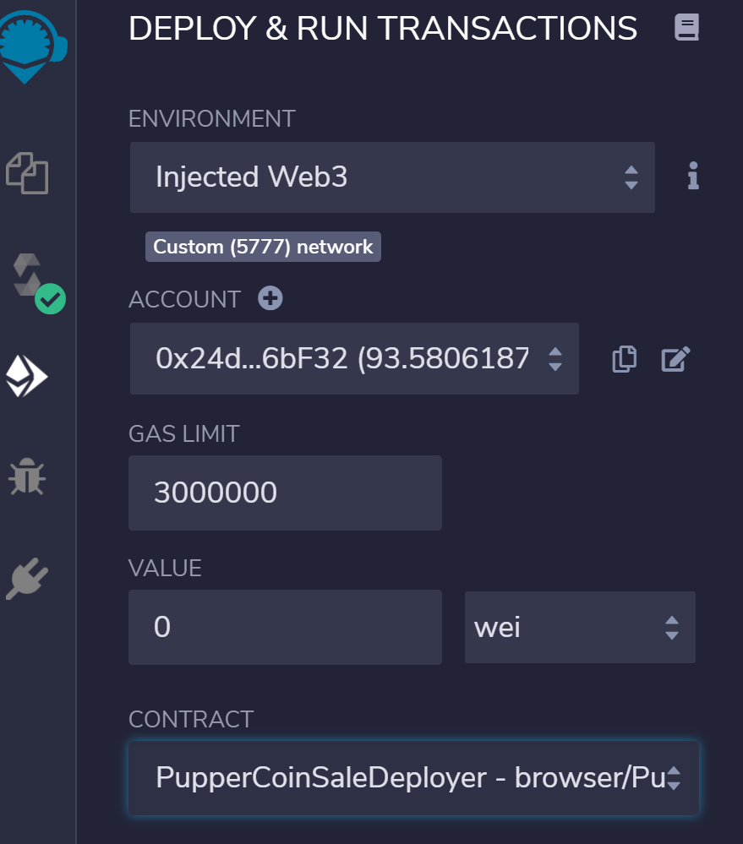

1. Open Deploy and fill in fields and hit “Transact”

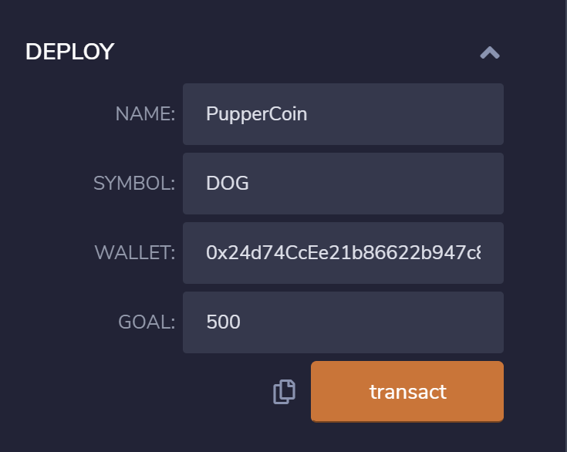

1. Confirm transaction via MetaMask

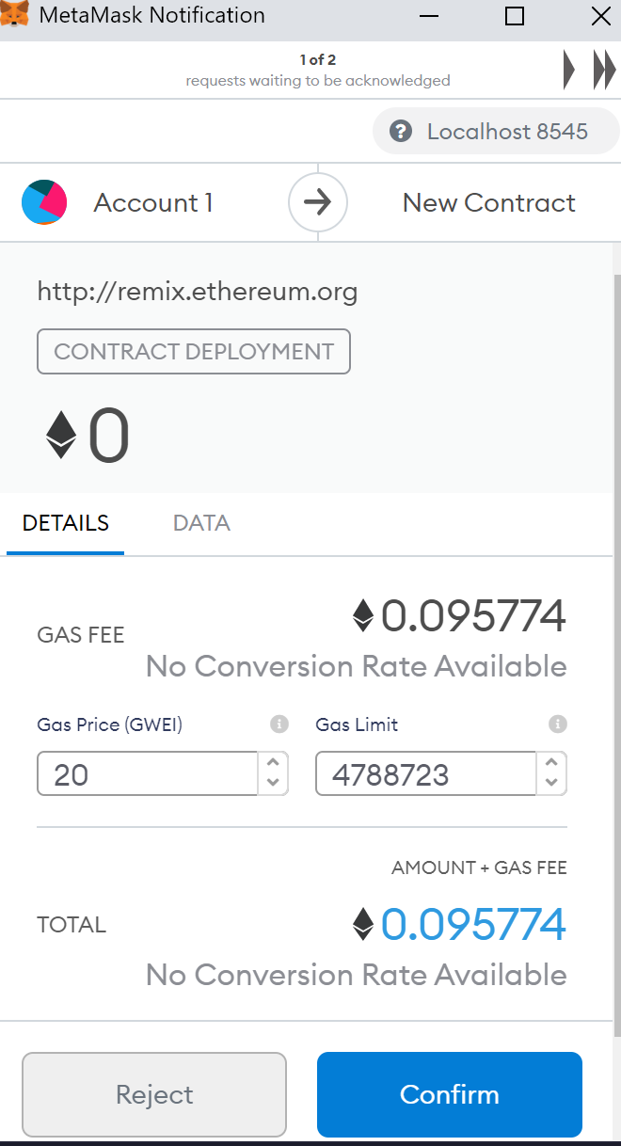

1. Confirm contract deployed:

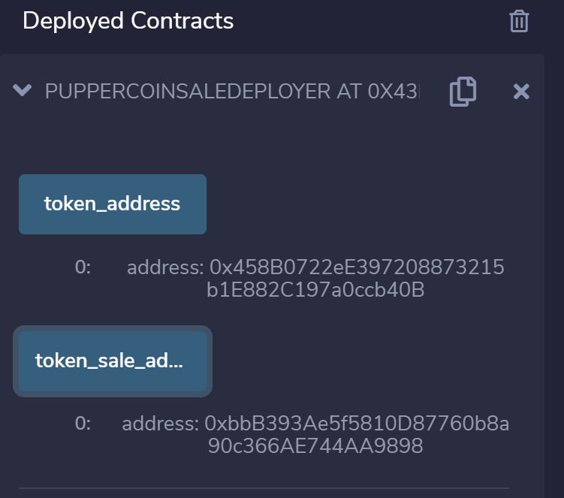

1. Change Contract to PupperCoinSale

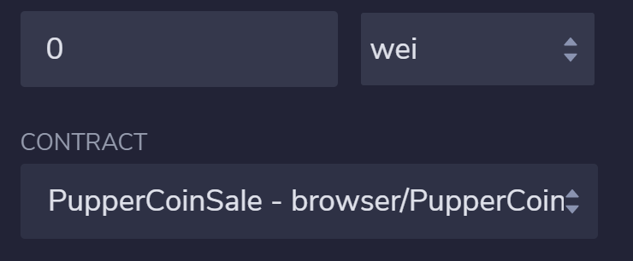

1. Go to the deployed PupperCoinSaleDeployed contract and copy the token_sale_address and paste it in the At Address

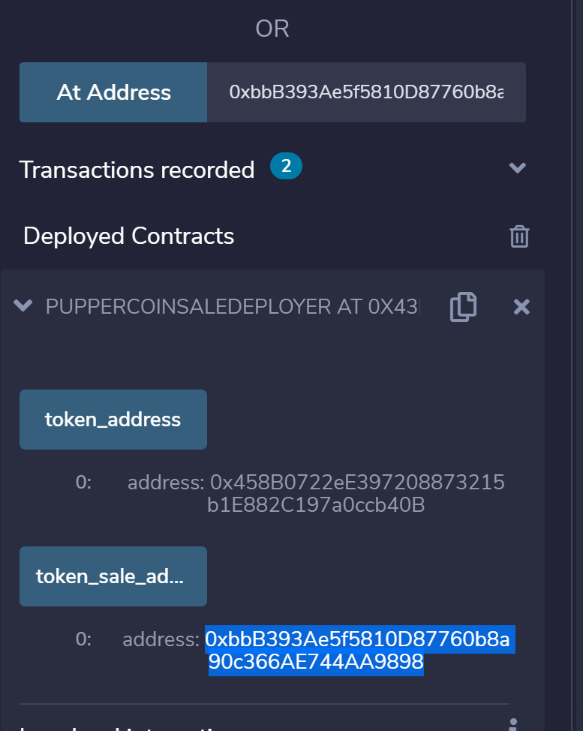

1. Switch contract to PupperCoin

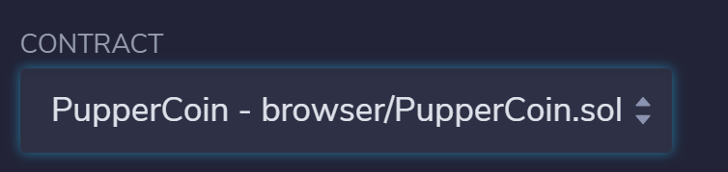

1. Go to the deployed PupperCoinSaleDeployer, copy the token_address and paste in the At Address for the PupperCoin

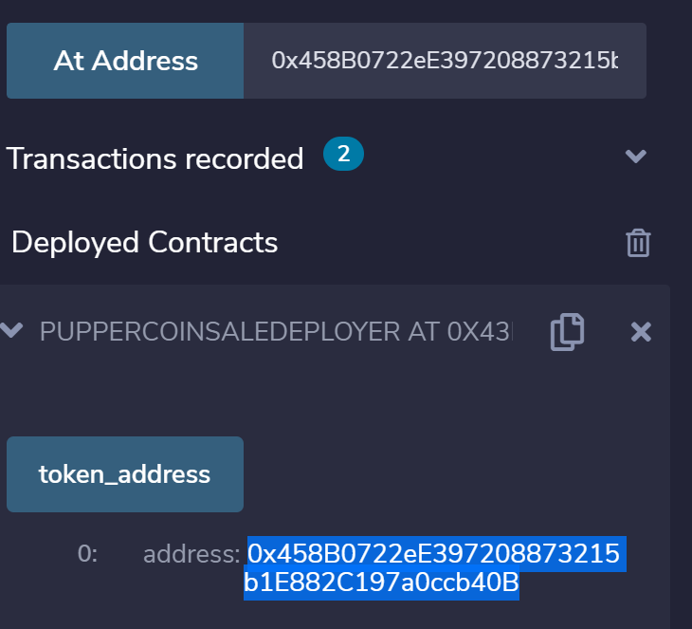

1. Open the deployed at the PupperCoin contract and check the name, symbol and totalSupply (should this be zero??)

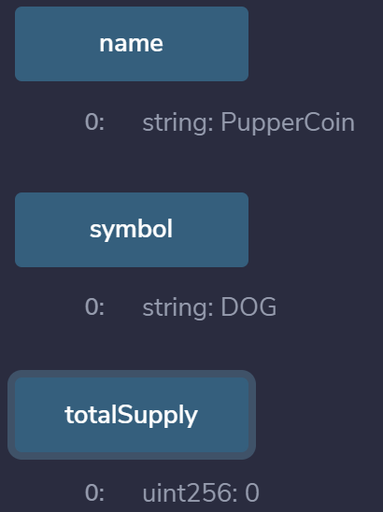

1. In the PupperCoin contract change the currency to Ether and enter a value (5)

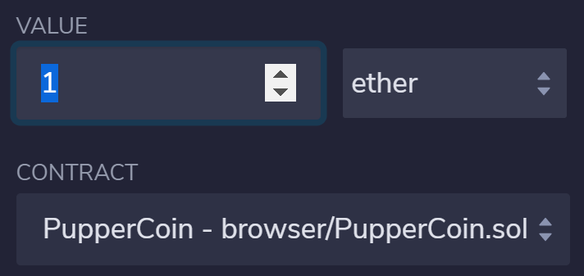

1. Go to Ganache and copy a unused address and scroll to the deployed PupperCoinSale contract, paste the newly copied address into the buyTokens box and hit buyTokens
2. Confirm it worked, open the PupperCoin deployed contract and refresh the totalSupply to confirm there is now an amount

